US NAVY WW2 VETERAN WHO SERVED IN FREMANTLE BASED BASED SUBMARINES TURNS 100

The Submarines Association of Australia was recently invited to participate in the celebration of the centenary of a US Submariner, Chief Warrant Officer John Price USN (Rtd), who had served on boats operating out of Fremantle during the Second World War. The SAA was represented by LCDR Mike Hardwick RAN (Rtd), who has presented John with a letter of congratulations from the SAA. Mike has authored the attached article on John’s career and the ceremony. Mike Hardwick was also the commissioning XO of Training Ship Orion at Jindabyne NSW, which was named after HMAS Orion.

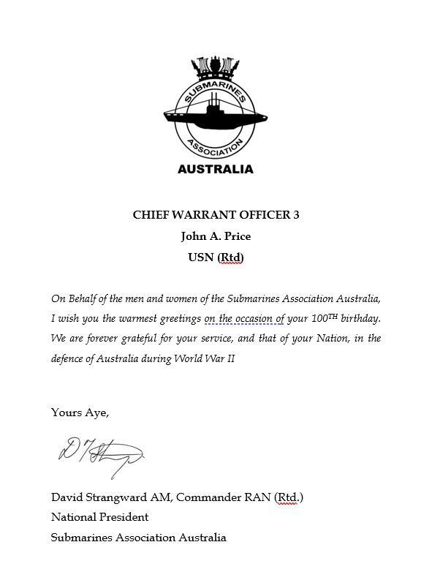

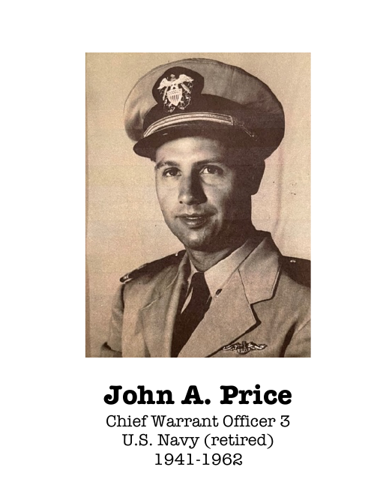

United States Navy submarine centenarian – an Australian connection

In February 2024, the Veterans’ Book Club (VBC) of Carroll County Public Library, Finksburg, Maryland, USA celebrated the 100th birthday of John A. Price, Chief Warrant Officer 3, United States Navy (Retired).

John served in USN submarines during WWII, including a period based in Fremantle, Western Australia.

Following is a speech that was delivered during the VBC celebration.

‘John Anthony Price, Service number 224-38-49, Chief Warrant Officer 3, United States Navy (retired), born 25 February, 1924.

‘John joined the United States Navy in New York City, New York on 16 September, 1941, almost three months before the Japanese surprise attack on Pearl Harbor.

‘John’s initial submarine or boat posting was for submarine qualification training in USS O-6, hull number SS-67.
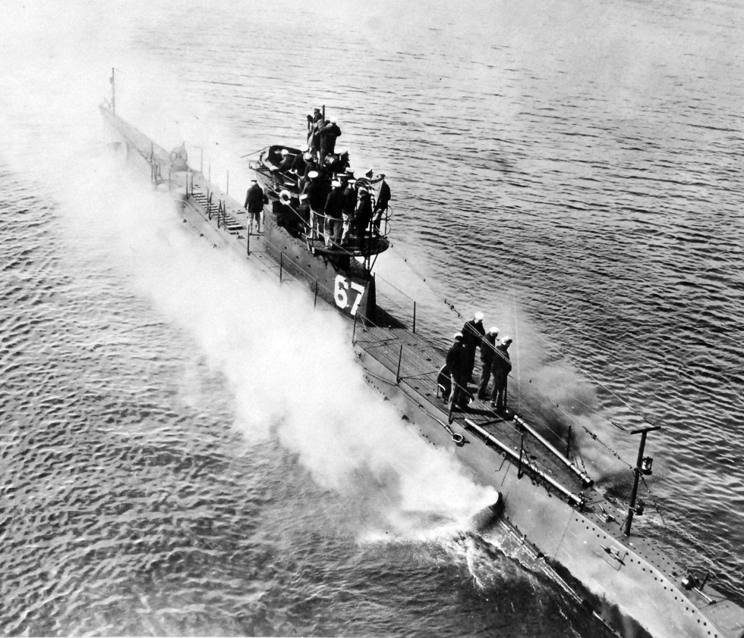

USS O-6

‘USS O-6 was initially commissioned in June 1918, decommissioned in 1931, recommissioned as a training platform in February 1941 and finally decommissioned in September 1945.

‘Given her age, it would be reasonable to conclude that operating and maintaining O-6 during her second commission would have been a challenge.

‘On completion of stringent testing, challenging training and proof of his mettle in O-6, John earned the coveted designation ‘qualified in submarines’ with the accompanying dolphins pin. His specialty was electrician’s mate.

‘During 1944, John was posted to the commissioning crew of Balao-class submarine USS Piranha.

‘After commissioning in February 1944, Piranha undertook set-to-work trials and workups in inhospitable east coast USA waters. She then transited the Panama Canal, arriving in Pearl Harbor on 18 May 1944.

‘On 14 June 1944, Piranha commenced her maiden operational patrol in an area known as Convoy College. The area laid across the principal Japanese convoy routes between Formosa, Luzon and the Asiatic mainland.

‘Piranha was part of a coordinated attack group known as the Mickey Finns, comprising USS Guardfish, USS Thresher, USS Apogon and Piranha.

On 11 July 1944, the attack group encountered a Japanese convoy. Piranha fired three torpedoes, sinking the 6,504 ton passenger-cargo ship Nichran Maru.

‘On 16 July, Piranha sank the 5,733 ton passenger-cargo ship, Seatle Maru, which was loaded to the gunwales with Japanese troops.

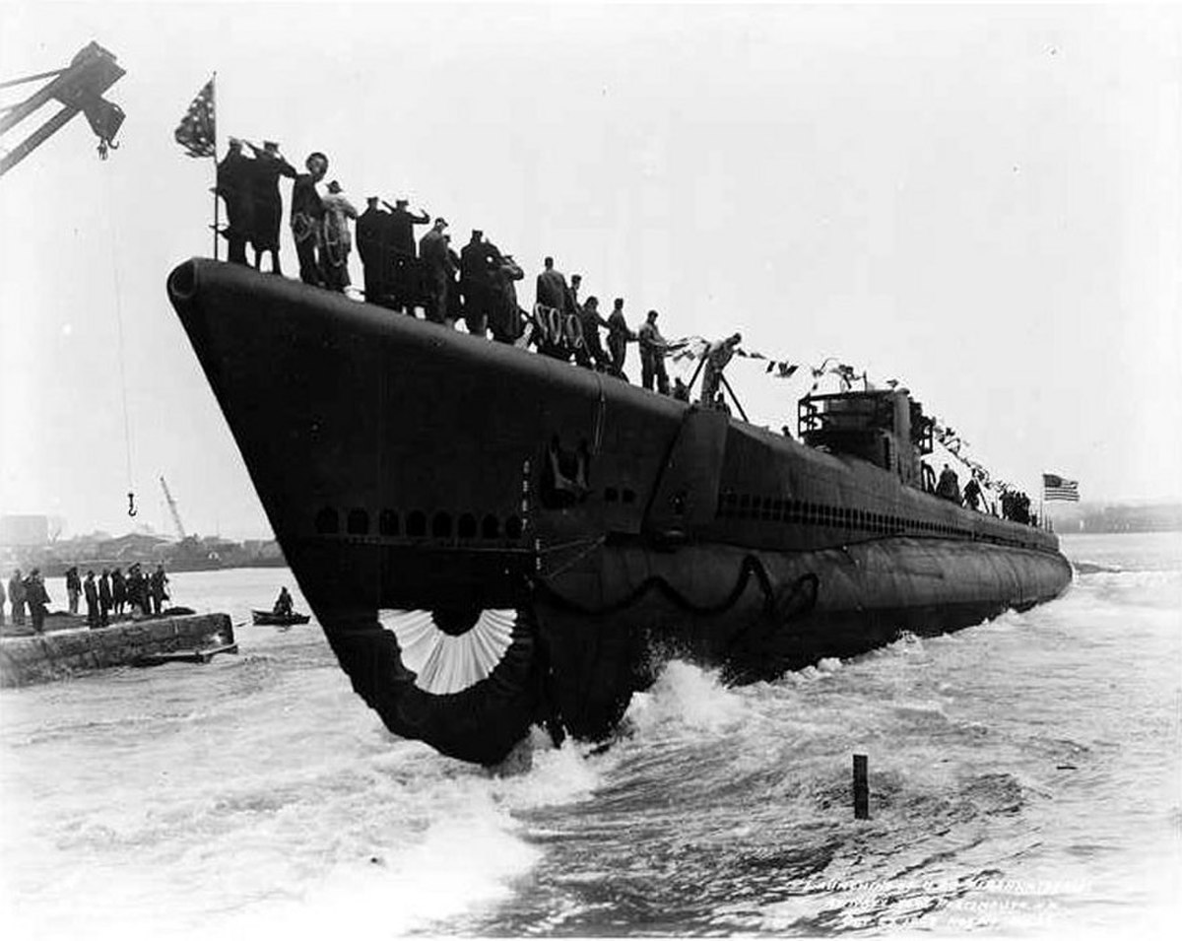

USS Piranha Launching

‘Piranha undertook two more patrols before John transferred to USS Croaker on 26 November, 1944.

‘John served in USS Croaker commencing with her third war patrol. She patrolled in the Luzon Straits and South China Sea during December 1944 to February 1945.

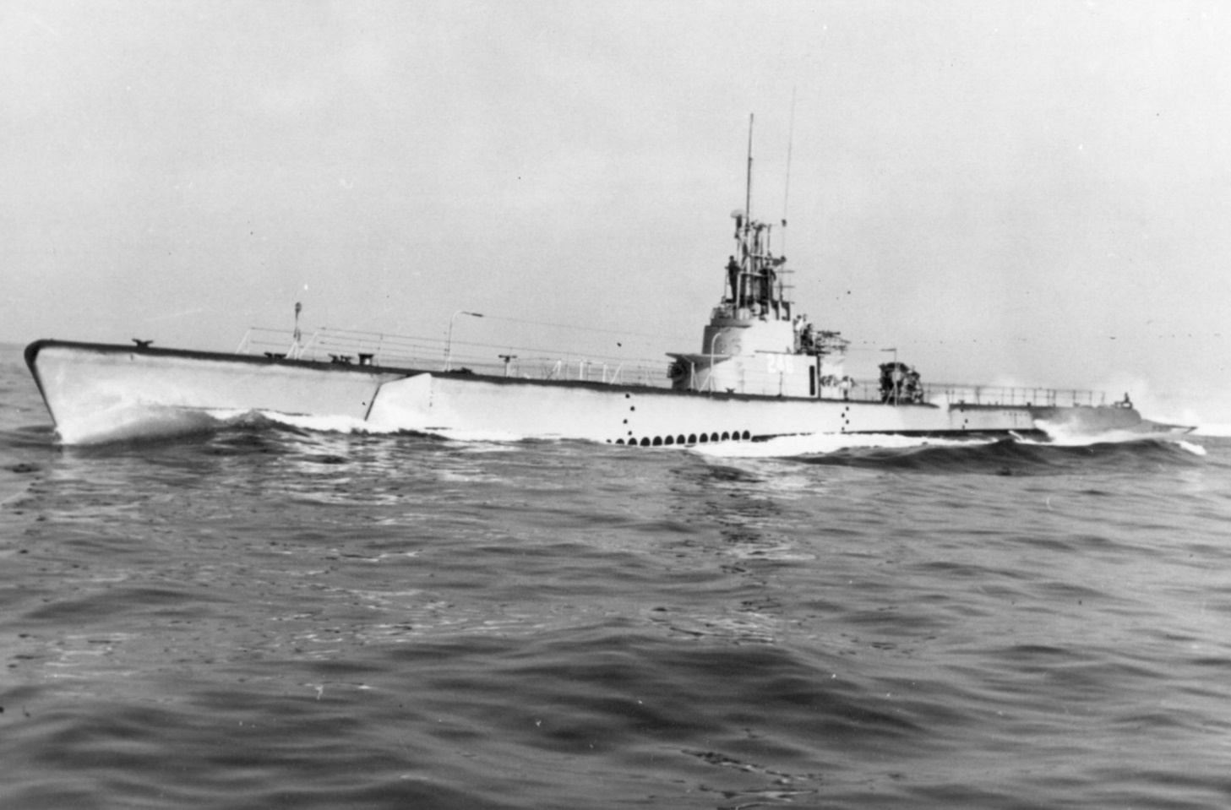

USS Croaker

‘Croaker found no contacts with enemy shipping. However, she provided essential lifeguard service during strikes on Luzon, preparatory to the allied amphibious invasion landings on Lingayen Gulf, the Philippines.

‘On completion of her third patrol, Croaker refitted in and operated out of Fremantle, Western Australia.

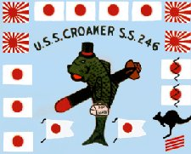

USS Croaker Battle Flag

‘Croaker’s battle patch displays a kangaroo image. The image does not depict one of Croaker’s kills; rather, the patch symbolises the boat’s Australian connection!

‘USS Croaker is now on display at Buffalo and Erie County Military Park in Buffalo, New York. She still wears her well-earned battle patch.

‘During the remainder of WWII, John subsequently served in USS Caiman, and USS Guavina.

‘One hundred and seventy American, British and Dutch submarines were based in, operated out of and were maintained in Fremantle, Western Australia during WWII; supposedly secretly!?

‘One hundred and twenty six of the boats were those of the US Navy.

‘USS Croaker and USS Caiman were among the USN boats based in Fremantle.

‘The Fremantle War Memorial features a 21 inch torpedo mounted in memory of USN submarines lost while on patrol out of Fremantle.

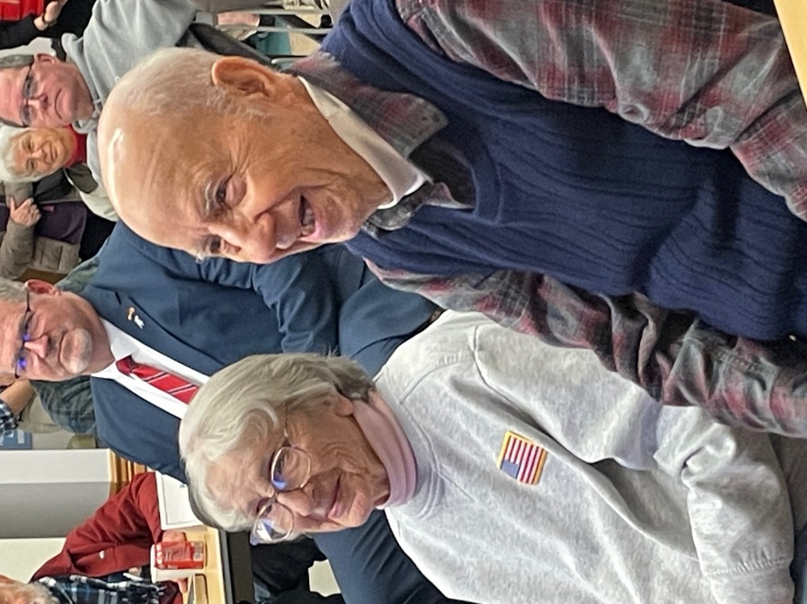

John and Nina Price on his 100th Birthday

‘On his 99th birthday celebration with VBC, John regaled that, while ashore in Fremantle and Brisbane, he learned to sing Waltzing Matilda; on that birthday occasion he accurately recited a few of the ballad’s stanzas.

‘John said that he learned the ballad from Aussie sailors; at a pub, or several, in Fremantle and Brisbane!

‘John’s WWII career in boats was that as an electrician’s mate. After a 21 year navy career, in March 1962, he was placed on the USN Retired List as Chief Warrant Officer 3.’

At the VBC birthday celebration, John was presented with a number of appreciation certificates, including a letter of congratulations and thanks from Submarines Association Australia.

‘John’s birthday occurs coincidental with his wife, Nina’s birthday – she turned 97 on the same day. John and Nina have been married for 73 years.

Authored by W. Michael Hardwick, Lieutenant Commander, Royal Australian Navy (Retired)

Photos:

1. Chief Warrant Officer 3, John A. Price, United States Navy (Retired)

2. USS 0-6 underway off New London, Connecticut, in 1942

3. Launch of USS Piranha

4. USS Croaker’s battle patch

5. Allied submarines’ memorial plaque at Fremantle, Western Australian

6. Submarines Association Australia letter of congratulations and thanks to CWO3 John A. Price USN (Retired)

7. John and Nina Price at the Veterans’ Book Club birthday celebrations, Carroll County, Maryland

